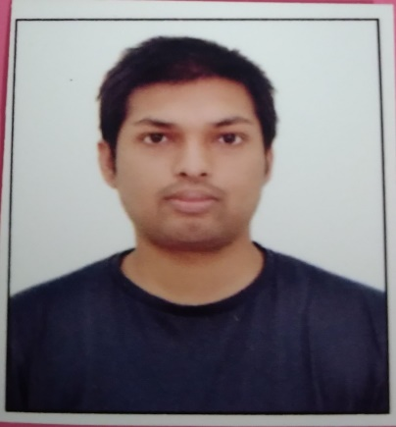

**EDUCATION**

Bachelors in Computer Science Engineering | Chandigarh University, Gharuan

*Session: 2019-Present | 7.72*

Intermediate (CBSE) |Lucknow Public School, Lucknow

*Session: 2017-2018 |* 78.4 %



Ashish Kumar Verma

# Address: 247 Eldeco Lucknow, UP 226025

E-mail: [*19bcs2887@gmail.com*](mailto:19bcs2887@gmail.com)

# Phone: +91 6388584602

LinkedIn[: Ashish Kumar Verma | LinkedIn](https://www.linkedin.com/in/ashish-kumar-verma-0a69631bb/" \o "link )

**PROFESSIONAL SUMMARY**

A well-organized, creative and goal- oriented graduate possessing excellent communication, problem-solving and leadership skills with a flair to explore suitable avenues in Computer Science Engineering while developing advanced projects with efficiency and quality.

**TECHNICAL COMPETENCIES**

C | C++ | Java | Python

**FAMILIAR WITH**

JavaScript | ReactJS | NodeJS | C#

GCP | AWS |Unity 3D | ML |

**INTERPERSONAL SKILLS**

Team Leadership **|** Management & Coordination **|** Decision Making

**INTERESTS & HOBBIES**

Trekking **|** Gaming**|** Travelling

**|** Reading **|**

**LANGUAGES KNOWN**

English **|** Hindi **|**

Matriculation (CBSE) | Lucknow Public School, Lucknow

*Session: 2015-2016 | 9.2 CGPA*

**TRAINING & PROJECTS**

**High Radius | Intern**

Jan 2022- April 2022 **Link :** [Invoice Management System](https://github.com/ash8080/HighRadius/tree/main/AI-Enabled-B2B-FINTECH-Management-main/WebContent)

* Built ​a full stack Invoice Management Application ​using ReactJs, JDBC, Java and JSP.
* Built a ​responsive Receivables Dashboard ​and a ​Customer Details page.
* Data visualization using HighCharts.
* Searching and Advanced Searching ​operations on the invoices.
* Integrated and Deployed the ML Model ​for predicting the first partial payment amount using Flask.

**Technophilla by IIT Bombay** **| Trainee**

May 2021-July 2021

* Training ML Model using Dataset from Kaggle
* Testing our Model on real data
* Accomplishment of Face Mask Detection & Tracking Project

**Game Developer | Self**

Nov 2020 - April 2020  **Link :** [Midnight Runner - Play Store](https://play.google.com/store/apps/details?id=com.CyberCop.MidnightRunner)

* Multiple Level Scene Generator
* Animation & Rigging of 3D Character
* Full UI development

**ACADEMIC ACHIEVEMENTS**

* Rank 25/8400 University Student Ranking In GFG
* 6 star in problem Solving in Hacker Rank
* Certificate of Machine Learning, University of Washington

**CERTIFICATIONS & AWARDS**

* AWS Fundamental Specialization
* Google Cloud **Facilitator** Program 2021
* Introduction To Data Science

**EXTRA CURRICULAR & CO-CURRICULAR ACHIEVEMENTS**

* Unity Game Developer
* 5 Star in Java at Hacker Rank